Software Testing Report

Traffic Data Analyzer

Joshua Thomas, Roger Harley

Table of Contents

1.0 Unit Tests 3

2.0 Coverage Report 4

3.0 Requirements Acceptance Testing 5

# Unit Tests

NOTE: These software unit tests are a hypothetical. We were unable to deliver the final product within specifications so these are the tests that would have taken place, had the software been properly completed.

| **No** | **Test Case** | **Expected Results** | **Actual Results** |
| --- | --- | --- | --- |
| **1.0** | **Database upload** |  |  |
| 1.1 | Test files other than a .db file | File explorer does not allow a user to select a file other than .db | File explorer does not allow a user to select a file other than .db |
| 1.2 | Test empty database | Display error message and exit | Display error message and exit |
| **2.0** | **Data selection options** |  |  |
| 2.1 | Testing incorrect parameters | Inform the user that there is no data matching the criteria and return to selection screen | Inform the user that there is no data matching the criteria and return to selection screen |
| 2.2 | Testing data selection | The user should be presented with a diagram or table of the selected data within the selected parameters | The user is presented with a diagram or table of the selected data within the selected parameters |
| 2.3 | Testing main menu return | After viewing the selected data and/or saving the result, the user should be returned to the main menu | After viewing the selected data and/or saving the result, the user should be returned to the main menu |
| 2.4 | SQL injection techniques should be tested | The program correctly sanitises any free user input and the SQL search parameters don’t respond to the query | The program correctly sanitises any free user input and the SQL search parameters don’t respond to the query |
| 2.5 | Testing the generated visual graphs | The program displays the correct graph type, with an accurate representation of the selected data. | The program displays the correct graph type, with an accurate representation of the selected data. |
| **3.0** | **Data selection options** |  |  |
| 3.1 | Testing data update function | The program should fetch the latest version of the .csv file and subsequently create a local database based off the data | The program is unable to fetch the .csv file as there is no static download link that can be implemented into the code |

|  |
| --- |
|  |

# Coverage Report

The image shown on the right shows the generated coverage report for the NSW Traffic Penalty Analyser. Furthermore, all of the functions generated are called (100%) meaning that this program has complete Function coverage.

Only one branch of the project is called, however there is only 1 branch altogether, meaning that there is 100% Branch coverage.

Condition Coverage, there are no interchangeable Boolean values, therefore 0 / 0 were tested meaning that there is 100% Condition coverage.

Between the two files, the Analyser function when run uses 84% of the lines included in the code. The Database creator however, uses 100% of the created lines. The PyCharm generated coverage report is attached below.

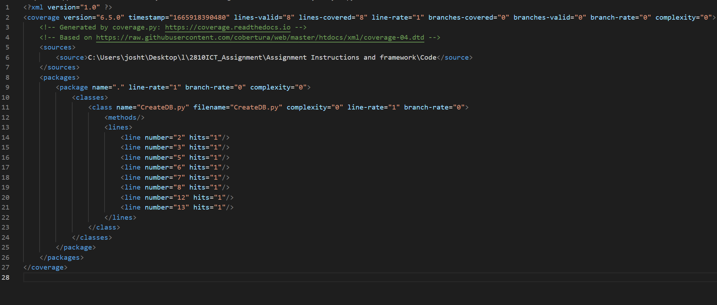

# Requirements Acceptance Testing

(You will need to fill out the column on the left with the requirements listed in software design documents and the columns on the right with the results of your own testing)

| **Software  Requirement No** | **Test** | **Implemented (Full /Partial/ None)** | **Test Results (Pass/ Fail)** | **Comments (for partial implementation or failed test results)** |
| --- | --- | --- | --- | --- |
| 1 | The program shall open into a ‘main menu’ showcasing all available options presented to the user. | Partial | Pass | Main menu is shown to users, but no options are presented to them. |
| 2 | The program shall provide multiple descriptive text boxes with a brief description of what each user selection does/ performs to the data. | None | N/A | Unfortunately the program has no information on implemented data selection inputs as it was not completed in time. |
| 3 | The program shall provide users filtering options such as date/time, penalty details, etc. |  |  | Unfortunately the program has no implemented data selection inputs as it was not completed in time. |
| 4 | The program shall provide users with a finalization option that takes the selected options and completes various operations on the collected data in order to output the desired results. |  |  | Unfortunately the program has no implemented data selection inputs as it was not completed in time. |
| 5 | The program shall have the functionality to read and fetch available traffic penalty data downloaded as a .csv file from the provided source, attached below. | None |  | This feature was attempted and successful at first, however the download link for the csv constantly changes and couldn’t be hardcoded. |
| 6 | The program shall create a localized formatted database using the python PANADS library. | Full | Pass | The application successfully creates a database using MySQL and PANDAS |
| 7 | The program shall interact with said database by utilizing mySQL, with correct formatting used so that each selected option generates a personalized query command | Partial | Pass | MySQL is used to both create and interact with the created database. |
| 8 | The program shall limit the use of allowable user input, and where provided, the program will insure the text is thoroughly ‘sanitized’ in order to harden the program against attacks such as SQL injection. | None | N/A | Unfortunately the program has no implemented user inputs as it was not completed in time. |
| 9 | Once all selections have been chosen and the finalizing button pressed, the program shall open a new window displaying the user with the requested data | None | N/a | Unfortunately the program has no implemented data selection inputs as it was not completed in time. |
| 10 | Upon the finalization, the program may (depending on user settings) generate a selected data visualisation model. Such models include, Box chart, line graph, scatterplot, etc. This will be generated using the python library ‘matplotlib’. | None | N/A | Unfortunately the program has no implemented data selection inputs or outputs as it was not completed in time. |
| 11 | The program shall provide users with the ability to save the generated chart to their machines locally as a .png file. | None | N/A | Unfortunately the program has no implemented data selection inputs or outputs as it was not completed in time. |
| 12 | Once the generated data is saved / discarded, the program shall remain operational and allow users to re-input settings and repeat the process over and over again. | Partial | Pass | The software never closes, however no new windows were ever created. |